Machine Learning:
Machine learning (ML) is a subset of artificial intelligence (AI) that focuses on building systems that learn from data and improve their performance over time without being explicitly programmed. The core of machine learning lies in its algorithms, which can be broadly classified into the following categories:
1. SUPERVISED LEARNING
In supervised learning, the algorithm learns from labeled data, meaning that each input comes with a corresponding output (label). The goal is to predict the output for new, unseen data.
Examples:
- Regression: Predicts continuous values.
  - Algorithms: Linear Regression, Polynomial Regression.
  - Use cases: Predicting house prices, stock market trends.

REGRESSION IN MACHINE LEARNING
Regression is a supervised learning technique used to predict continuous numerical values based on input data. It establishes a relationship between dependent and independent variables by fitting a line or curve to the data points. Here are some key aspects of regression, along with algorithms and real-world use cases:

LINEAR REGRESSION:
Linear Regression is one of the simplest and most commonly used algorithms in regression. It assumes a linear relationship between the input (independent) variables and the output (dependent) variable. The model tries to find the best-fitting straight line by minimizing the difference between the actual and predicted values.
- Example Use Case:
Predicting house prices based on features like square footage, number of bedrooms, and location. For instance, a house with 1,500 square feet in a prime area might have a higher predicted price than a similar-sized house in a less desirable location.
A1.SIMPLE LINEAR REGRESSION:
Simple Linear Regression
Simple Linear Regression is a basic supervised learning algorithm that models the relationship between two variables:
- Independent Variable (X) – The factor affecting the outcome (e.g., study hours).
- Dependent Variable (Y) – The predicted outcome (e.g., exam score).

Example: Predicting Exam Scores Based on Study Hours
Let’s say we want to predict a student’s exam score based on the number of hours they study. Here,
- X (Independent Variable): Study hours
- Y (Dependent Variable): Exam score
The relationship between study hours and exam scores can be represented by the equation of a straight line:
Y=β₀+β₁ X+ϵ
Where:
- Y: Predicted exam score
- Β₀ ​: Intercept (score when study hours = 0)
- Β₁: Slope (how much the score increases for each additional study hour)
- X: Study hours
- ϵ: Error term (unexplained variation)
How It Works
- Data Collection: Gather data from several students, e.g.:
  - Student A: 2 hours → 50 marks
  - Student B: 5 hours → 75 marks
  - Student C: 8 hours → 90 marks
- Model Training: Use Simple Linear Regression to find the best-fitting line that minimizes the difference between actual and predicted scores.
- Prediction: Once the model is trained, you can predict scores for new students. For example, if a student studies for 6 hours, the model might predict a score of 80.

A2. MULTIPLE LINEAR REGRESSION
Multiple Linear Regression is an extension of Linear Regression that uses multiple independent variables to predict a single dependent variable. It helps in understanding how various factors influence an outcome, making it particularly useful for complex scenarios like student performance.
Example Use Case for Students: Predicting GPA
Let’s consider a scenario where a student’s GPA depends on several factors. Here, the dependent variable is the GPA, and the independent variables might include:
- Number of study hours per week (hard work)
- Availability of quality books and study materials
- Faculty guidance and teaching quality
- Performance in class presentations
- Participation in group discussions
- Attendance percentage
- Sleep duration per night
The Multiple Linear Regression model would analyze how each of these factors contributes to the student’s GPA.
How It Works
The relationship between the GPA (Y) and the independent variables (X1,X2,X3,…X_1, X_2, X_3,) can be expressed as:
Y=β₀+β₁X₁+ β₂X₂+ β₃X₃+…+ϵ
Where:
- Y: Predicted GPA
- β0​: Intercept (GPA when all independent variables are zero)
- β₁, β₂, β₃, … Coefficients showing the impact of each independent variable
- X₁, X₂, X₃, … Independent variables (study hours, attendance, etc.)
- ϵ : Error term (accounts for variability not explained by the model)
Real-World Example
Suppose the data for 10 students shows the following:
- A student with high study hours, good faculty support, and consistent class participation has a GPA of 3.9.
- Another student with fewer study hours and poor class attendance has a GPA of 2.5

B. CLASSIFICATION (NON LINEAR):
Classification is a supervised learning technique used to predict discrete labels or categories based on input data. In classification problems, the goal is to assign data points (such as students, emails, or images) to predefined classes or categories. For example, in the context of students, classification might predict whether a student will pass or fail a course based on certain features.
Example: Predicting Student Performance (Pass/Fail)
Let’s consider an example where we use classification to predict whether a student will pass or fail a course based on features like study hours, attendance, and participation.
Classification Algorithms:
B!. Logistic Regression
Logistic Regression is a simple yet effective classification algorithm used to predict the probability of a binary outcome (e.g., pass/fail). It calculates the likelihood of an event occurring based on the input features.
Example Use Case for Students:
Predicting whether a student will pass or fail a course. If the student studies for 10 hours and has 90% attendance, the model can predict whether they are likely to pass (1) or fail (0).
Real-World Example: Classifying Students' Pass/Fail Status
Imagine we have a dataset with the following features for a group of students:
- Study Hours
- Attendance Percentage
- Previous Exam Scores
- Class Participation
We want to classify the students as either "Pass" or "Fail" based on these features. The data might look like this:
Student | Study Hours | Attendance % | Previous Exam Score | Class Participation | Pass/Fail
A | 10 | 90 | 80 | High | Pass
B | 4 | 60 | 50 | Low | Fail
C | 8 | 85 | 75 | Medium | Pass
D | 2 | 40 | 30 | Low | Fail
Now, we can apply a classification algorithm to predict whether a new student (E) with 7 study hours, 80% attendance, and medium class participation will pass or fail the course. Based on the patterns learned from previous students, a classifier like Logistic Regression or Decision Tree will make this prediction.

2. UNSUPERVISED LEARNING
Unsupervised learning works on unlabeled data. The goal is to uncover hidden patterns, structures, or relationships in the data.
Examples:
- Clustering: Groups similar data points.
  - Algorithms: k-Means, Hierarchical Clustering, DBSCAN.
  - Use cases: Customer segmentation, anomaly detection.
- Dimensionality Reduction: Reduces the number of features while retaining essential information.
  - Algorithms: Principal Component Analysis (PCA), t-SNE, Autoencoders.
  - Use cases: Data visualization, feature extraction.
4. Reinforcement Learning
In reinforcement learning, an agent learns by interacting with an environment and receiving feedback in the form of rewards or penalties. The goal is to maximize cumulative rewards over time.
Examples:
- Algorithms: Q-Learning, Deep Q-Networks (DQN), Policy Gradient Methods.
- Use cases: Game-playing AI (e.g., AlphaGo), robotics, autonomous vehicles.

Commonly Used Tools and Libraries
- Python Libraries: scikit-learn, TensorFlow, PyTorch, Keras, XGBoost.
- Frameworks: Google TensorFlow, Facebook PyTorch.

Steps in Machine Learning Workflow
- Data Collection and Preprocessing: Collect data and clean it for analysis.
- Feature Selection and Engineering: Select important features or create new ones.
- Model Selection: Choose the appropriate algorithm.
- Training the Model: Fit the model to the training data.
- Evaluation: Assess the model’s performance using metrics like accuracy, precision, recall, etc.
- Deployment: Use the trained model to make predictions on real-world data.

What is Bias?
To make predictions, our model will analyze our data and find patterns in it. Using these patterns, we can make generalizations about certain instances in our data. Our model after training learns these patterns and applies them to the test set to predict them.
Bias is the difference between our actual and predicted values. Bias is the simple assumptions that our model makes about our data to be able to predict new data.
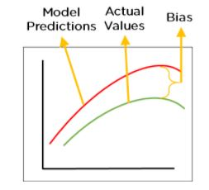
Figure 2: Bias
When the Bias is high, assumptions made by our model are too basic, the model can’t capture the important features of our data. This means that our model hasn’t captured patterns in the training data and hence cannot perform well on the testing data too. If this is the case, our model cannot perform on new data and cannot be sent into production.
This instance, where the model cannot find patterns in our training set and hence fails for both seen and unseen data, is called Underfitting.
The below figure shows an example of Underfitting. As we can see, the model has found no patterns in our data and the line of best fit is a straight line that does not pass through any of the data points. The model has failed to train properly on the data given and cannot predict new data either.
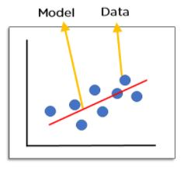
Figure 3: Underfitting

- Low Bias: A low bias model will make fewer assumptions about the form of the target function.
- High Bias: A model with a high bias makes more assumptions, and the model becomes unable to capture the important features of our dataset. A high bias model also cannot perform well on new data.
OR
- Low Bias: Low bias value means fewer assumptions are taken to build the target function. In this case, the model will closely match the training dataset.

- High Bias: High bias value means more assumptions are taken to build the target function. In this case, the model will not match the training dataset closely.

- Some examples of machine learning algorithms with low bias are Decision Trees, k-Nearest Neighbours and Support Vector Machines. At the same time, an algorithm with high bias is Linear Regression, Linear Discriminant Analysis and Logistic Regression.

Ways to reduce High Bias:
High bias mainly occurs due to a much simple model. Below are some ways to reduce the high bias:
- Increase the input features as the model is underfitted.
- Decrease the regularization term.
- Use more complex models, such as including some polynomial features.

What is Variance?
Variance is the very opposite of Bias. During training, it allows our model to ‘see’ the data a certain number of times to find patterns in it. If it does not work on the data for long enough, it will not find patterns and bias occurs. On the other hand, if our model is allowed to view the data too many times, it will learn very well for only that data. It will capture most patterns in the data, but it will also learn from the unnecessary data present, or from the noise.
“variance tells that how much a random variable is different from its expected value”
We can define variance as the model’s sensitivity to fluctuations in the data. Our model may learn from noise. This will cause our model to consider trivial features as important.
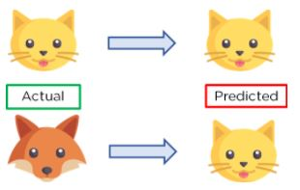
Figure 4: Example of Variance
In the above figure, we can see that our model has learned extremely well for our training data, which has taught it to identify cats. But when given new data, such as the picture of a fox, our model predicts it as a cat, as that is what it has learned. This happens when the Variance is high, our model will capture all the features of the data given to it, including the noise, will tune itself to the data, and predict it very well but when given new data, it cannot predict on it as it is too specific to training data.
Hence, our model will perform really well on testing data and get high accuracy but will fail to perform on new, unseen data. New data may not have the exact same features and the model won’t be able to predict it very well. This is called Overfitting.
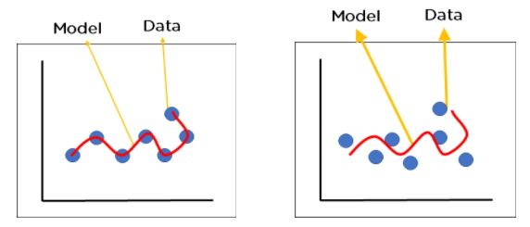
Figure 5: Over-fitted model where we see model performance on, a) training data b) new data
OR
” A model that shows high variance learns a lot and perform well with the training dataset, and does not generalize well with the unseen dataset. As a result, such a model gives good results with the training dataset but shows high error rates on the test dataset.
”

variance tells that how much a random variable is different from its expected value. Ideally, a model should not vary too much from one training dataset to another, which means the algorithm should be good in understanding the hidden mapping between inputs and output variables. Variance errors are either of low variance or high variance.
Low variance means there is a small variation in the prediction of the target function with changes in the training data set. At the same time, High variance shows a large variation in the prediction of the target function with changes in the training dataset.
Since, with high variance, the model learns too much from the dataset, it leads to overfitting of the model. A model with high variance has the below problems:
- A high variance model leads to overfitting.
- Increase model complexities.
Usually, nonlinear algorithms have a lot of flexibility to fit the model, have high variance.
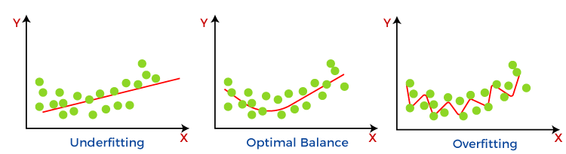
Some examples of machine learning algorithms with low variance are, Linear Regression, Logistic Regression, and Linear discriminant analysis. At the same time, algorithms with high variance are decision tree, Support Vector Machine, and K-nearest neighbours.

Different Combinations of Bias-Var

iance
There are four possible combinations of bias and variances, which are represented by the below diagram:
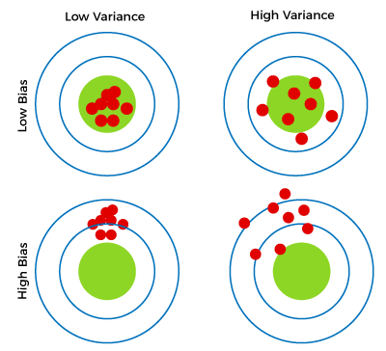
- Low-Bias,Low-Variance:
The combination of low bias and low variance shows an ideal machine learning model. However, it is not possible practically.
- Low-Bias, High-Variance: With low bias and high variance, model predictions are inconsistent and accurate on average. This case occurs when the model learns with a large number of parameters and hence leads to an overfitting
- High-Bias, Low-Variance: With High bias and low variance, predictions are consistent but inaccurate on average. This case occurs when a model does not learn well with the training dataset or uses few numbers of the parameter. It leads to underfitting problems in the model.
- High-Bias, High-Variance: With high bias and high variance, predictions are inconsistent and also inaccurate on average.

How to identify High variance or High Bias?
High variance can be identified if the model has:
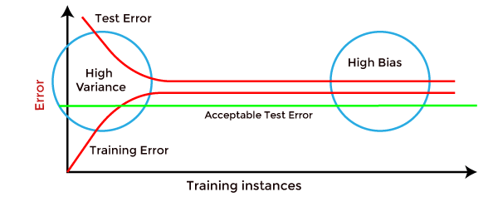
- Low training error and high test error.
High Bias can be identified if the model has:
- High training error and the test error is almost similar to training error.

Bias-Variance Trade-Off
While building the machine learning model, it is really important to take care of bias and variance in order to avoid overfitting and underfitting in the model. If the model is very simple with fewer parameters, it may have low variance and high bias. Whereas, if the model has a large number of parameters, it will have high variance and low bias. So, it is required to make a balance between bias and variance errors, and this balance between the bias error and variance error is known as the Bias-Variance trade-off.
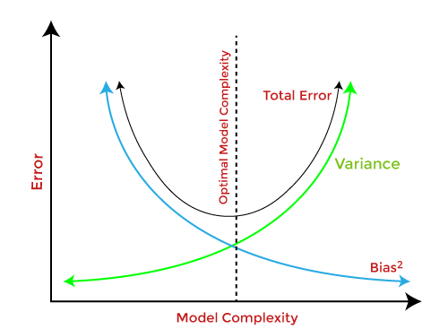
ADVERTISEMENT
For an accurate prediction of the model, algorithms need a low variance and low bias. But this is not possible because bias and variance are related to each other:
- If we decrease the variance, it will increase the bias.
- If we decrease the bias, it will increase the variance.
Bias-Variance trade-off is a central issue in supervised learning. Ideally, we need a model that accurately captures the regularities in training data and simultaneously generalizes well with the unseen dataset. Unfortunately, doing this is not possible simultaneously. Because a high variance algorithm may perform well with training data, but it may lead to overfitting to noisy data. Whereas, high bias algorithm generates a much simple model that may not even capture important regularities in the data. So, we need to find a sweet spot between bias and variance to make an optimal model.
Hence, the Bias-Variance trade-off is about finding the sweet spot to make a balance between bias and variance errors.

